KOREA INSTITUTE FOR INDUSTRIAL ECONOMICS AND TRADE (KIET)
Sejong, Republic of Korea
To: Gartner Global IP & Content Compliance (Attn: Ms. Sejal Kalra)
From: Heekwon Kyung and Sanghoon Kim (KIET)
Re: Content-compliance mock-up — Gartner-referencing excerpts, manuscript "The Reverse Ascent" (World Development submission). Case Ref #2025-139654
Date: 30 July 2026
Enclosure: This document (editable), 17 pp.: implementation summary; verbatim excerpts of the data section and source appendix; all fourteen Gartner-referencing figures as they appear; complete in-text mention inventory.
Content-Compliance Mock-up
This mock-up contains every excerpt of the manuscript in which Gartner data, derived statistics, or Gartner-based visualisations appear, laid out exactly as they will appear in the published paper. Two format confirmations are requested in Section 1; all other elements follow the guidance in your letter.

1. Implementation of the three requirements
(a) Full attribution. A dedicated appendix ("Appendix I — Gartner source documents and content-compliance statements", reproduced verbatim in Section 3) lists every Gartner document used: each market-share workbook by title, document number and publication; the Devices quarterly document series by document number; and every methodology document with its Gartner ID, publication date, and analyst byline as printed on the document (four series, 2009–2026). Figure captions point to this appendix.
(b) Required disclaimers. Every author-drawn graphic based on Gartner research carries the caption line "Graphic created by the authors based on Gartner research (source documents in Appendix I). Calculations performed by the authors." All derived statistics and econometric estimates are covered by the blanket statement in Appendix I; twenty of twenty figure captions carry a compliance line.
(c) No commingling. No graphic mixes Gartner data with data from any other source. Where the argument pairs a Gartner-based perspective with a trade-data perspective (Figures 4, 11 and 12), the figure consists of separate panels, each a self-contained graphic with its own independent source line; the centre element of Figure 4 is an explicitly labelled data-free schematic. The hypotheses summary (Figure 1) contains no numerical values from any source.

Two points for confirmation
1) Attribution of data deliverables (in-file bylines). Each Gartner market-share deliverable carries its authorship byline inside the workbook itself, in the cover block of the Contents sheet; these in-file bylines are reproduced verbatim in Appendix I, Panel A, as the primary attribution, corroborated by the analyst lists on Gartner’s public document pages where those pages survive. Every edition’s byline is secured, including the 2010–2014 legacy files (bylines embedded as sheet text) and the 2021 edition, whose byline (eighteen analysts) was recovered from an intact copy of the same deliverable held in the companion project archive (the copy inspected here is a drawing-stripped extract) and cross-checked against the adjacent 2020 and 2022 in-file bylines and the era’s methodology bylines (Panel B). Please confirm that this attribution format — Gartner, [official title], [in-file byline], [document number], [publication date] — satisfies the “Author Name(s)” requirement.
2) Please confirm that the separate-panels-with-independent-source-lines format (Section 4: Figures 4, 11, 12) satisfies the no-commingling requirement.

2. Excerpt — Data section (verbatim)
Market data. are stable across vintages, while intermediate-year readings can shift by up to roughly 0.75 points as Gartner restates. Trade data. International trade flows come from the CEPII BACI database (Gaulier &amp; Zignago, 2010), the standard harmonization of UN Comtrade for multi-country, multi-year analysis at the HS6 level; it reconciles mirror flows and converts import values to FOB. BACI is used for trends and cross-product comparisons. For single-country balance levels we cross-check against reporter self-reports, since reconciliation redistributes flows involving non-specified partners; known issues — the “Other Asia” Taiwan convention, Hong Kong re-exports, and an IC-import undercount in recent years — are flagged where relevant and discussed in the limitations. Trade flows are taken from CEPII BACI V202601and the two horizons are stated per exhibit. We deliberately do not extend the trade layer with unreconciled 2025 customs returns, which would mix reporting bases across exhibits. Es

3. Excerpt — Appendix I (verbatim)
Compliance statements. All charts and graphics in this paper were created by the authors (Heekwon Kyung and Sanghoon Kim, KIET) based on Gartner research, CEPII BACI trade data, and the other sources cited; no graphic reproduces a Gartner-published exhibit. All derived statistics, aggregations, harmonized panels, and econometric estimates reported in this paper are calculations performed by the authors and do not represent Gartner published data. Gartner data and other-source data are not commingled within any single graphic; where a figure pairs perspectives from different sources, each panel is a separate graphic with its own source line.
Panel A. Gartner data documents used (market-share workbooks). Authorship of data deliverables. Each modern deliverable carries its authorship byline inside the file itself, in the cover block of the Contents sheet (stored in the workbook&#8217;s drawing layer rather than in cells): twenty of the thirty-one workbooks cited below carry such a byline, and these in-file bylines are reproduced in the rows below as the primary attribution, corroborated by the analyst lists on Gartner&#8217;s public document pages where those pages survive. Every deliverable on file &#8212; including the 2010&#8211;2014 legacy .xls files (bylines embedded as sheet text) and every device quarterly from 4Q14 onward &#8212; carries an in-file byline, with every edition&#8217;s byline now secured: the 2021 edition&#8217;s byline (eighteen analysts) was recovered from an intact copy of the same deliverable held in the companion project archive (the copy inspected here is a drawing-stripped extract), cross-checked against the adjacent 2020 and 2022 in-file bylines and the era&#8217;s methodology bylines (Panel B). The 2015&#8211;16 workbooks&#8217; internal vendor-coverage lookup is a coverage assignment, not authorship, and is not used for citation.
Devices market-share document series (quarterly workbooks underlying the harmonized 2011&#8211;2025 device panel): 1Q22 (doc. 765624); 1Q23 (doc. 787890); 1Q24 (doc. 808254); 1Q25 (doc. 832184); 2Q21 (doc. 757324); 2Q22 (doc. 773502); 2Q23 (doc. 787891); 3Q21 (doc. 758272); 3Q22 (doc. 778381); 3Q23 (doc. 787893); 3Q24 (doc. 824213); 4Q20 (doc. 741833); 4Q21 (doc. 765375); 4Q22 (doc. 778625); 4Q23 (doc. 808249); 4Q24 (doc. 825901). Additional quarterly documents in the same series are enumerated in the reproducibility package manifest.
Panel B. Gartner methodology documents (definitions and methodology; analyst bylines as printed).

Panel A — data documents
Document title | Doc. ID | Publication
Market Share: Semiconductor Applications, Worldwide, 2010 &#8212; printed byline: Bryan Lewis, Andrew Norwood, Mark Hung, Peter Middleton, Brady Wang, Jon Erensen, Jamie Wang, Sergis Mushell, Adriana Blanco, Steve Ohr, Joe Unsworth, Ben Lee, Paul O&#8217;Donovan, Alfonso Velosa, Hiroyuki Shimizu, Masatsune Yamaji, Masao Kuniba, Ganesh Ramamoorthy, Adib Ghubril, Gerald Van Hoy, Nolan Reilly | 212141 | March 2011
Market Share: Semiconductor Applications, Worldwide, 2011 &#8212; in-file byline: Bryan Lewis, Andrew Norwood, Mark Hung, Peter Middleton, Brady Wang, Jon Erensen, Jamie Wang, Sergis Mushell, Adriana Blanco, Steve Ohr, Joe Unsworth, Ben Lee, Paul O'Donovan, Alfonso Velosa, Hiroyuki Shimizu, Masatsune Yamaji, Masao Kuniba, Ganesh Ramamoorthy, Adib Ghubril, Michele Reitz, Roger Sheng, Philip Koh, Gerald Van Hoy and Nolan Reilly | 233379 | March 2012
Market Share: Semiconductor Applications, Worldwide, 2012 &#8212; in-file byline: Bryan Lewis, Andrew Norwood, Mark Hung, James Hines, Peter Middleton, Brady Wang, Jon Erensen, Jamie Wang, Sergis Mushell, Adriana Blanco, Steve Ohr, Joe Unsworth, Ben Lee, Paul O'Donovan, Alfonso Velosa, Hiroyuki Shimizu, Masatsune Yamaji, Masao Kuniba, Ganesh Ramamoorthy, Adib Ghubril, Amy Teng, Marielena Oppenheimer, Michele Reitz, Roger Sheng, Gerald Van Hoy, Nolan Reilly | 250903
Market Share: Semiconductor Applications, Worldwide, 2013 &#8212; in-file byline: Bryan Lewis, Andrew Norwood, James Hines, Mark Hung, Brady Wang, Jon Erensen, Jamie Wang, Sergis Mushell, Adriana Blanco, Steve Ohr, Joe Unsworth, Ben Lee, Paul O'Donovan, Alfonso Velosa, Hiroyuki Shimizu, Masatsune Yamaji, Masao Kuniba, Ganesh Ramamoorthy, Adib Ghubril, Amy Teng, Michele Reitz, Roger Sheng, R.M. Satish, Gerald Van Hoy, Nolan Reilly | 258292 | March 2014
Market Share: Semiconductors by End Market, Worldwide, 2025 &#8212; in-file byline (Contents cover block): Rajeev Rajput, Ben Lee, Guy Robertson, Jainendra Singh, Joseph Unsworth, Jon Erensen, Kartikay Gulani, Masatsune Yamaji, Menglin Cao, Roger Sheng, Shrish Pant, Warren Peng and Yashika Goyal Gartner Market Statistics | 846653 | April 2026
Market Share: Semiconductor Wafer Fab Equipment, Worldwide, 2025 &#8212; in-file byline (Contents cover block): Menglin Cao and Bob Johnson | 846972 | April 2026

Panel B — methodology documents (analyst bylines as printed)
Title | ID | Published/Refreshed | Analyst(s)
Market Definitions and Methodology: Semiconductor Chips and Electronic Equipment | G00849046 | 9 March 2026 | Rajeev Rajput
Market Definitions and Methodology: PCs, Tablets, | G00849005 | 23 March 2026 | Rishi Padhi

4. Excerpt — figures referencing Gartner (as they appear)
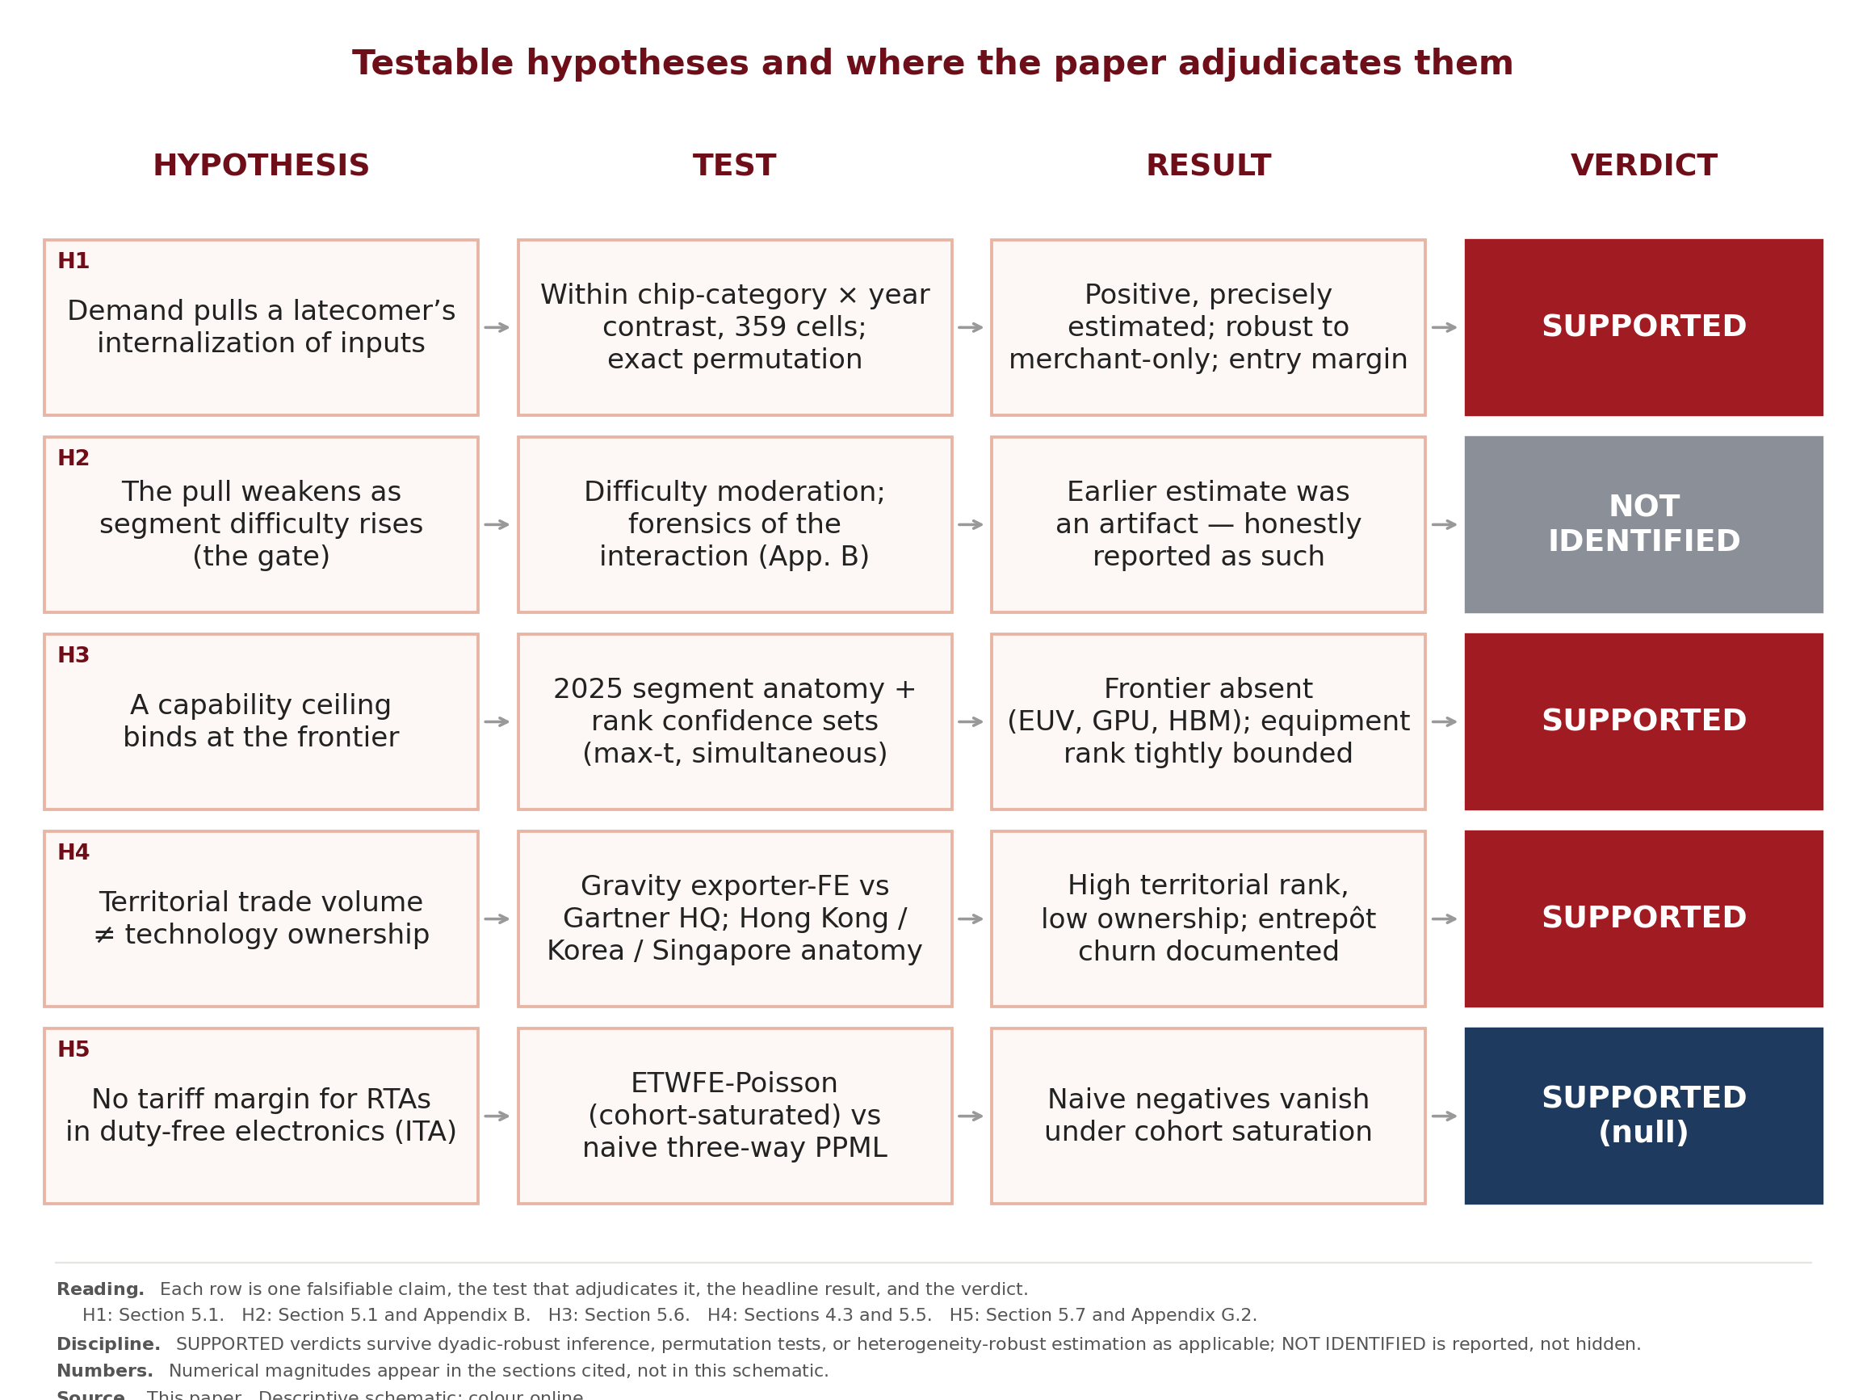
Figure 1. Five testable hypotheses: statement, test, result, verdict (Sections 2&#8211;5). Structured caption embedded in-figure; final numbering at copy-edit. Panels are separate graphics with independent sources (Gartner-based panel and trade-data panel; Appendix I). Graphics created by the authors; calculations performed by the authors.
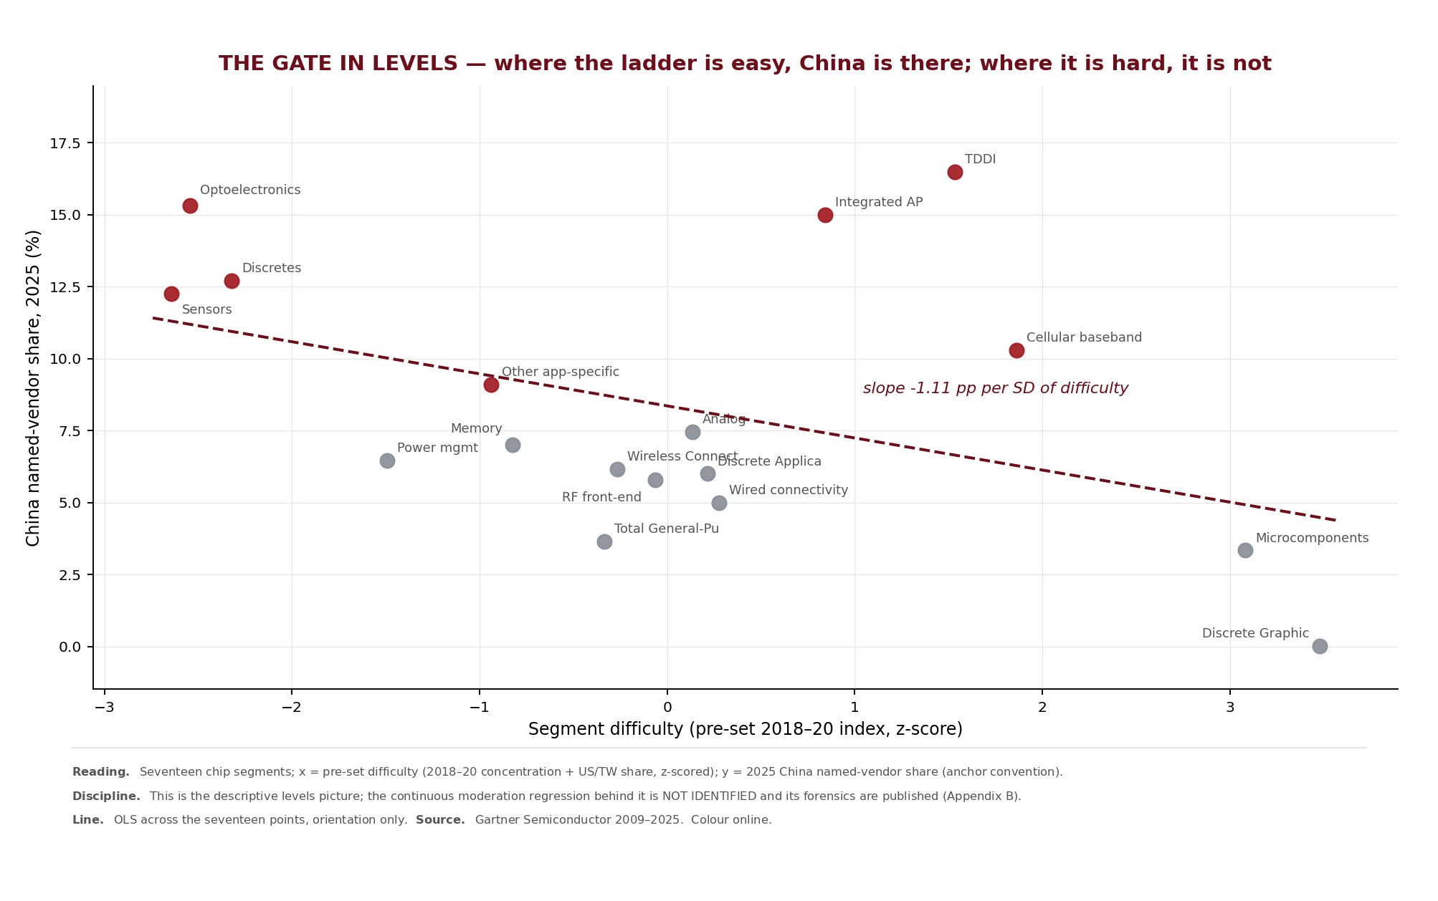
Figure 2. The reverse ascent — China’s position at three depths of the electronics value chain, 2011–2025. Chinese-brand device-shipment share (the entry rung), Chinese-headquartered merchant-semiconductor revenue share (one layer down), and named Chinese wafer-fabrication-equipment share (the deepest layer) plotted over time. The deeper the layer, the later and the lower its rise: each layer’s steepest climb arrives about four years after the one above (devices around 2015, chips around 2019, equipment around 2023), the equipment turn falling just after the October 2022 controls. Device share is all-device shipments; the semiconductor series is the China-headquarters-inclusive basis (named-vendor share lower); WFE is nine named toolmakers. Graphic created by the authors based on Gartner research (source documents in Appendix I). Calculations performed by the authors.
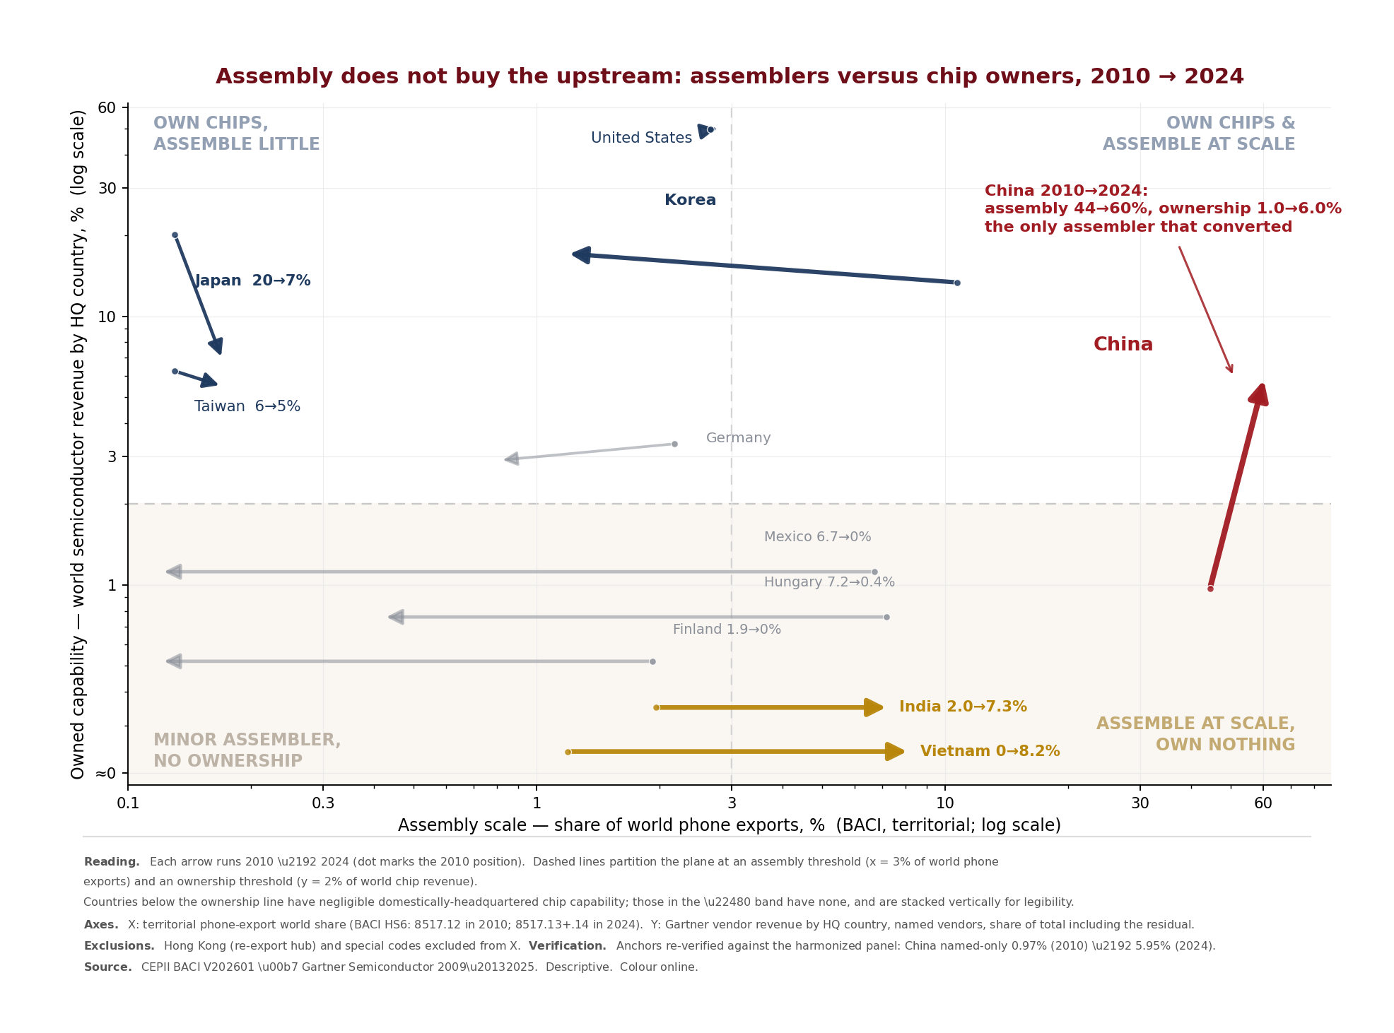
Figure 3. The gate in levels — seventeen chip segments, pre-set difficulty versus 2025 China named-vendor share (Section 5.1). Structured caption embedded in-figure; final numbering at copy-edit. Graphic created by the authors based on Gartner research (source documents in Appendix I). Calculations performed by the authors.
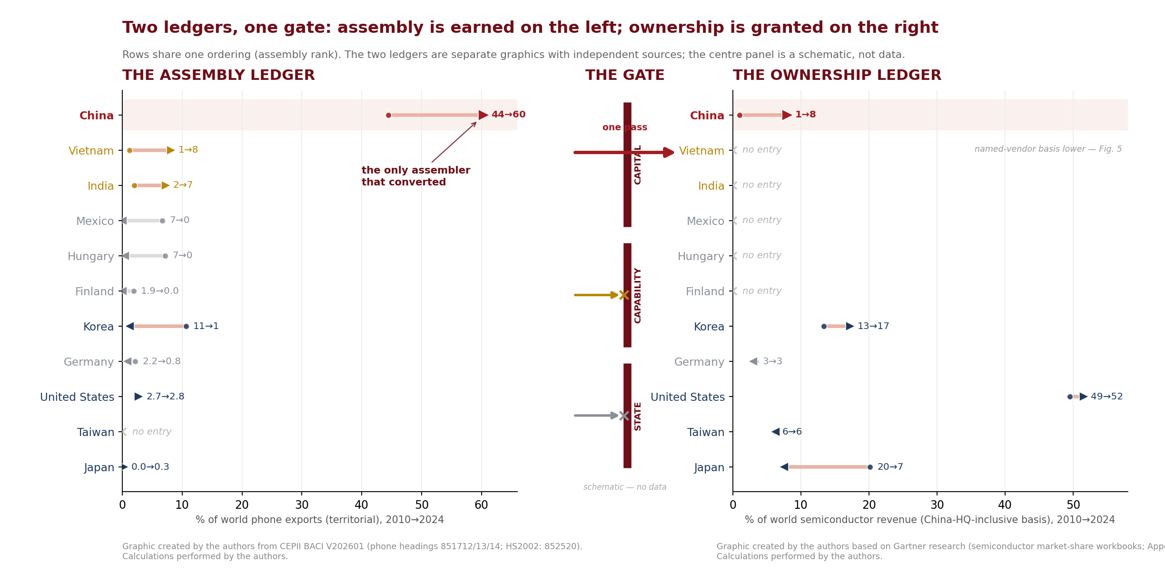
Figure 4. Assembly does not buy the upstream: assemblers and chip owners, 2010&#8211;2024 (Section 3). Structured caption embedded in-figure; final numbering at copy-edit. Panels are separate graphics with independent sources (Gartner-based panel and trade-data panel; Appendix I). Graphics created by the authors; calculations performed by the authors.
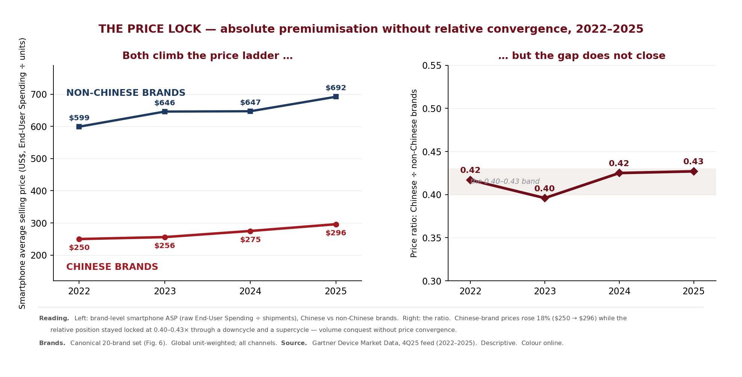
Figure 7. The Red Wave across device categories, 2011&#8211;2025 (Section 3). Structured caption embedded in-figure; final numbering at copy-edit. Graphic created by the authors based on Gartner research (source documents in Appendix I). Calculations performed by the authors.

Figure 8. The price lock: absolute premiumisation without relative convergence, 2022&#8211;2025 (Section 3). Structured caption embedded in-figure. Graphic created by the authors based on Gartner research (source documents in Appendix I). Calculations performed by the authors.
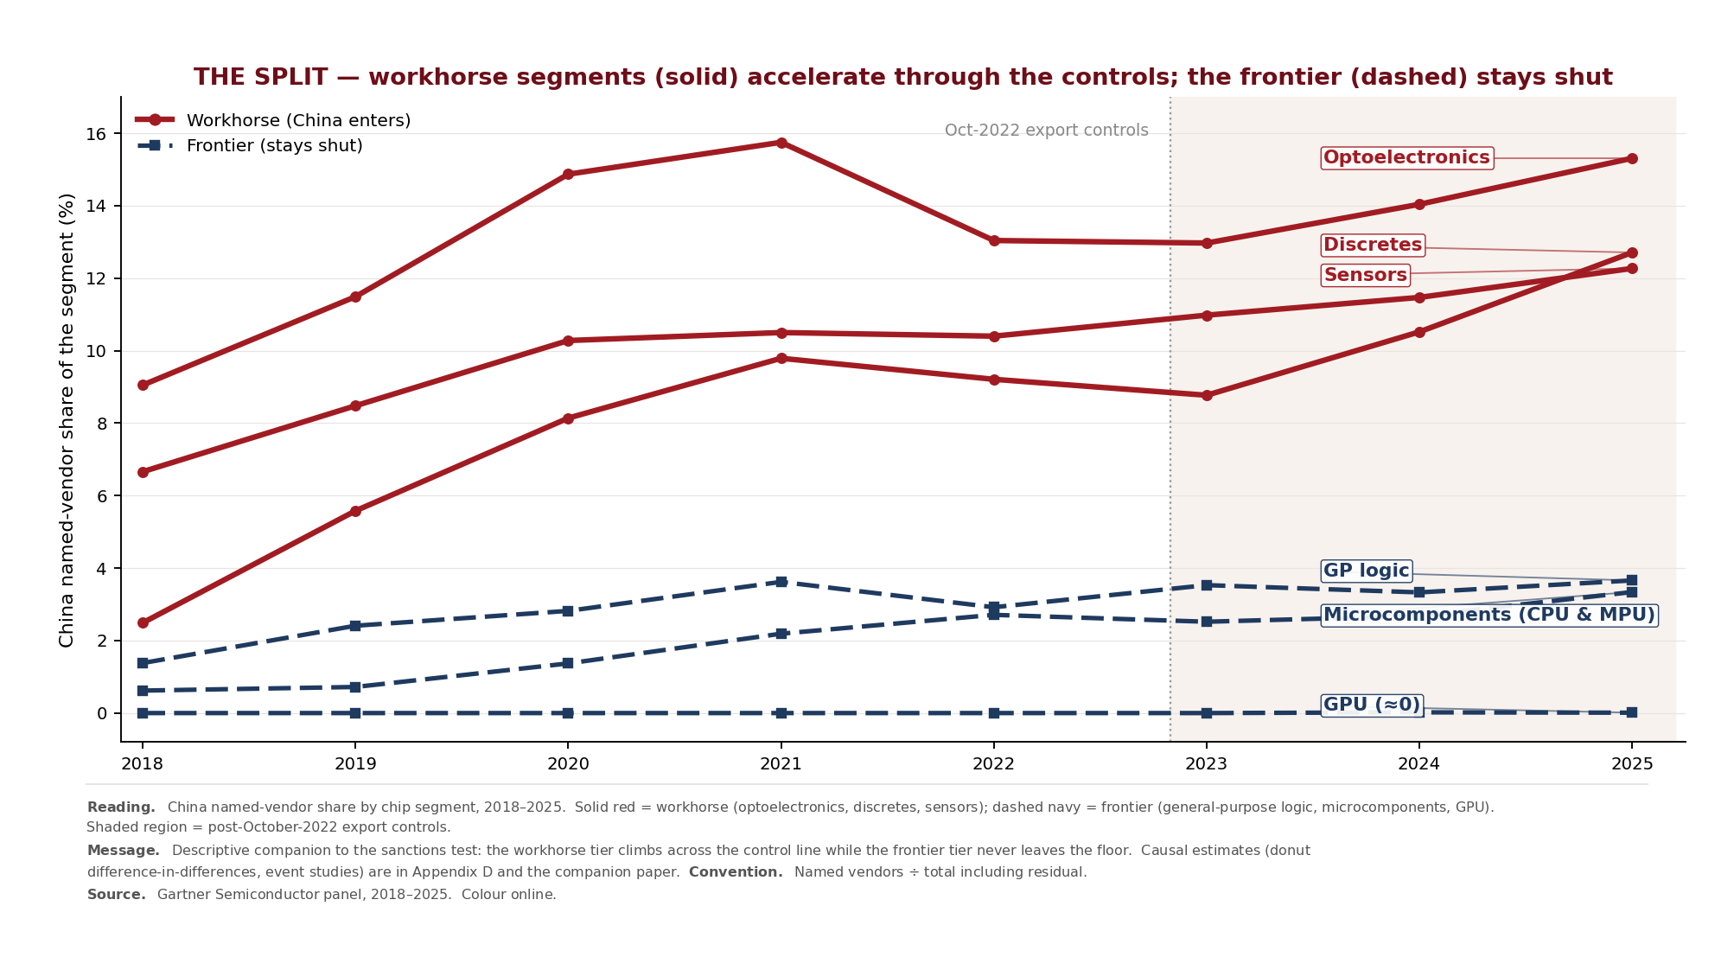
Figure 9. The split: workhorse versus targeted equipment segments around October 2022 (Section 5.2; descriptive &#8212; causal analysis in the companion paper). Structured caption embedded in-figure; final numbering at copy-edit. Graphic created by the authors based on Gartner research (source documents in Appendix I). Calculations performed by the authors.
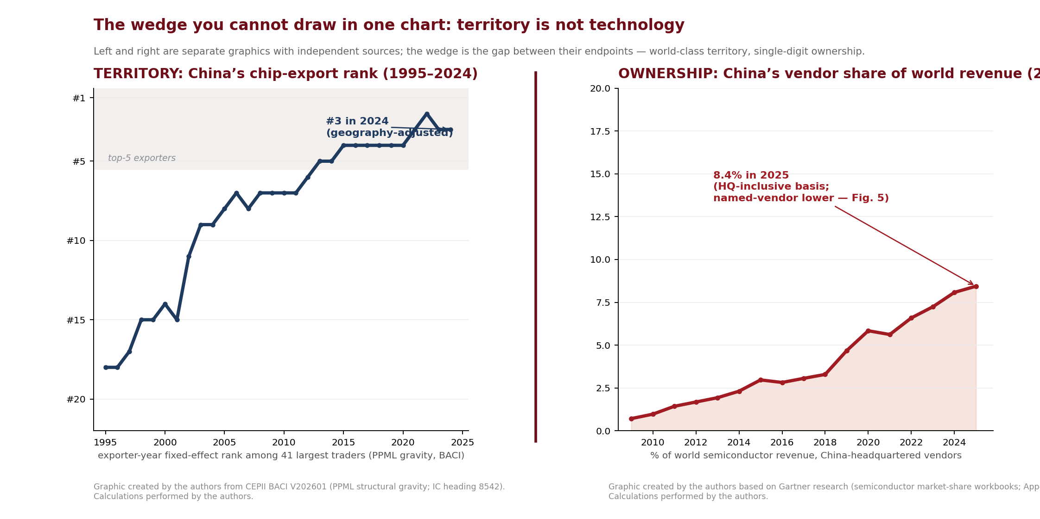
Figure 11. Territory versus ownership: the reverse-ascent wedge (Section 5.5). Structured caption embedded in-figure; final numbering at copy-edit. Panels are separate graphics with independent sources (Gartner-based panel and trade-data panel; Appendix I). Graphics created by the authors; calculations performed by the authors.

Figure 12. The double ceiling, with rank confidence sets (Section 5.6). Structured caption embedded in-figure; final numbering at copy-edit. Panels are separate graphics with independent sources (Gartner-based panel and trade-data panel; Appendix I). Graphics created by the authors; calculations performed by the authors.
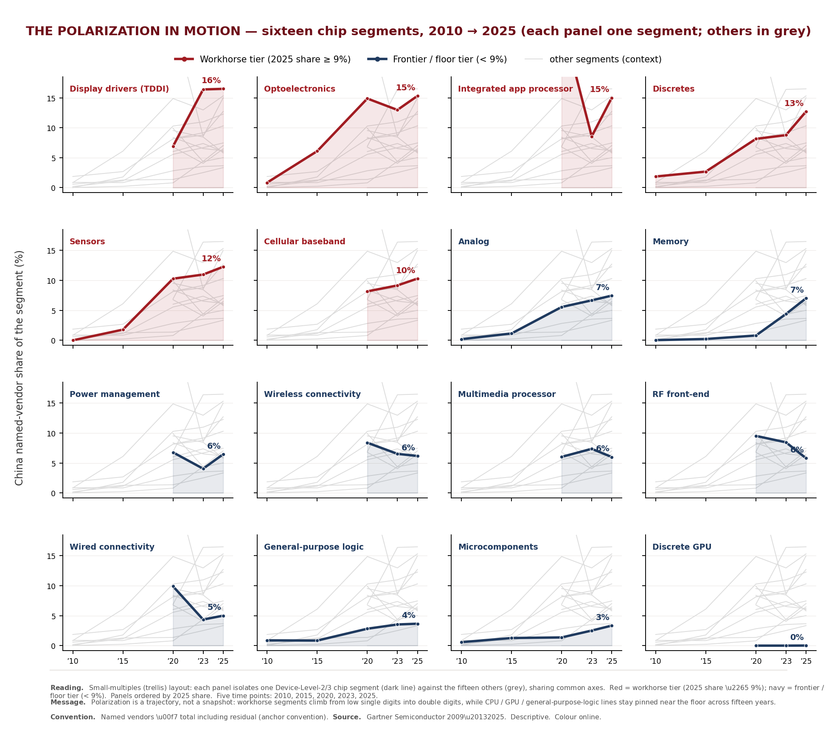
Appendix Figure A1. The wave travels through the consumer channel (companion to Section 3; see also Appendix G.4). Structured caption embedded in-figure; final numbering at copy-edit. (Appendix Figures A3 and A2.) Graphic created by the authors based on Gartner research (source documents in Appendix I). Calculations performed by the authors.
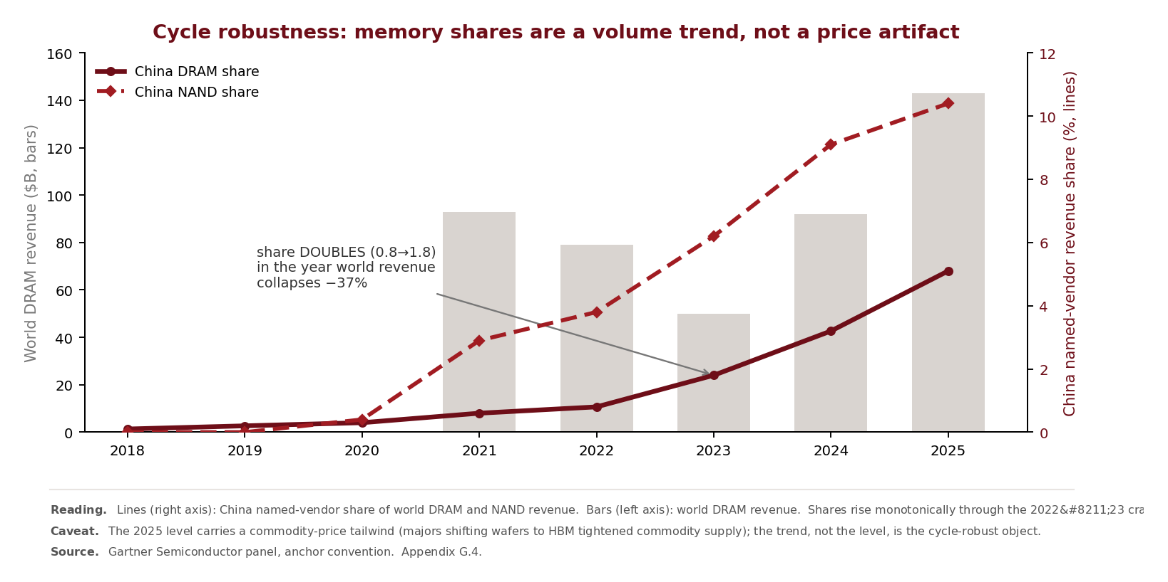
Appendix Figure A2. The polarization in motion: seventeen chip segments, 2010&#8594;2025 &#8212; the workhorse tier lifts off, the frontier tier never moves (Section 5.1). Structured caption embedded in-figure. Graphic created by the authors based on Gartner research (source documents in Appendix I). Calculations performed by the authors.
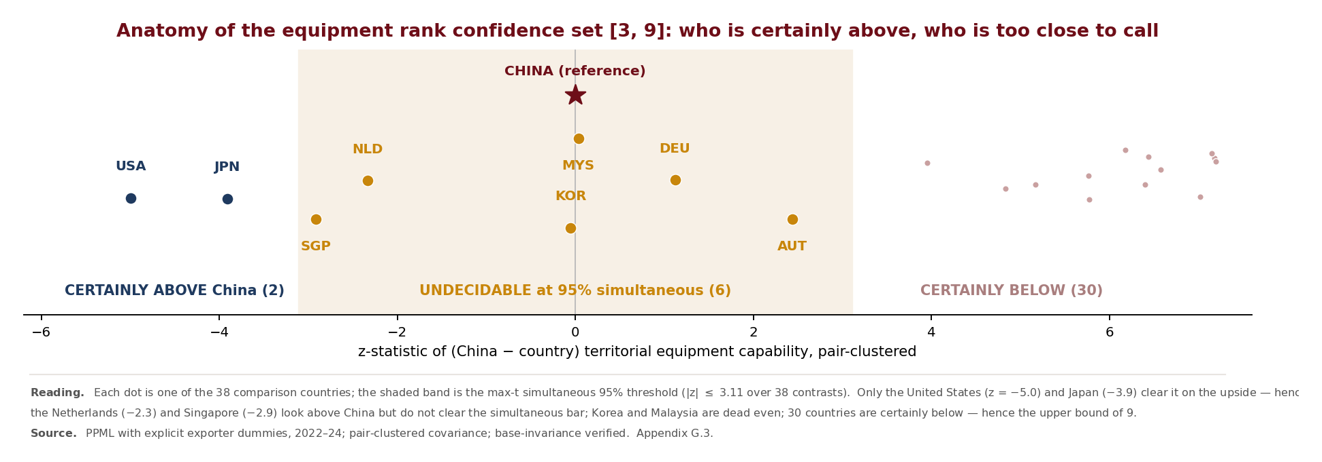
Appendix Figure A3. Cycle robustness of memory shares: China&#8217;s DRAM and NAND positions across two full price cycles (Section 5.1 companion). Structured caption embedded in-figure. Graphic created by the authors; sources as stated in the panel and Appendix I. Calculations performed by the authors.
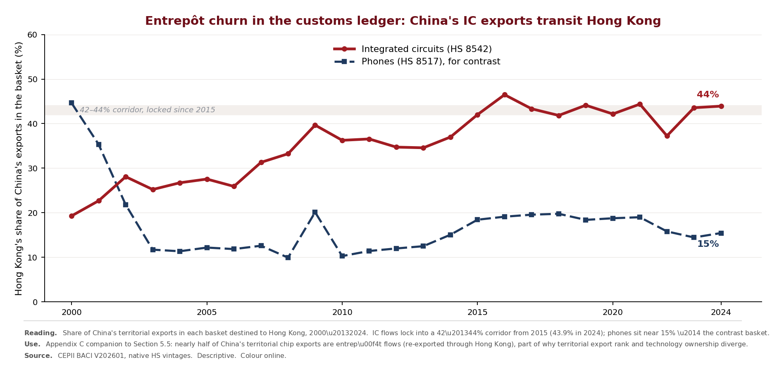
Appendix Figure A4. Anatomy of the equipment rank confidence set: two clearly above, six indistinguishable, thirty clearly below (Appendix G.3). (Appendix Figure A4.) Graphic created by the authors based on Gartner research (source documents in Appendix I). Calculations performed by the authors.
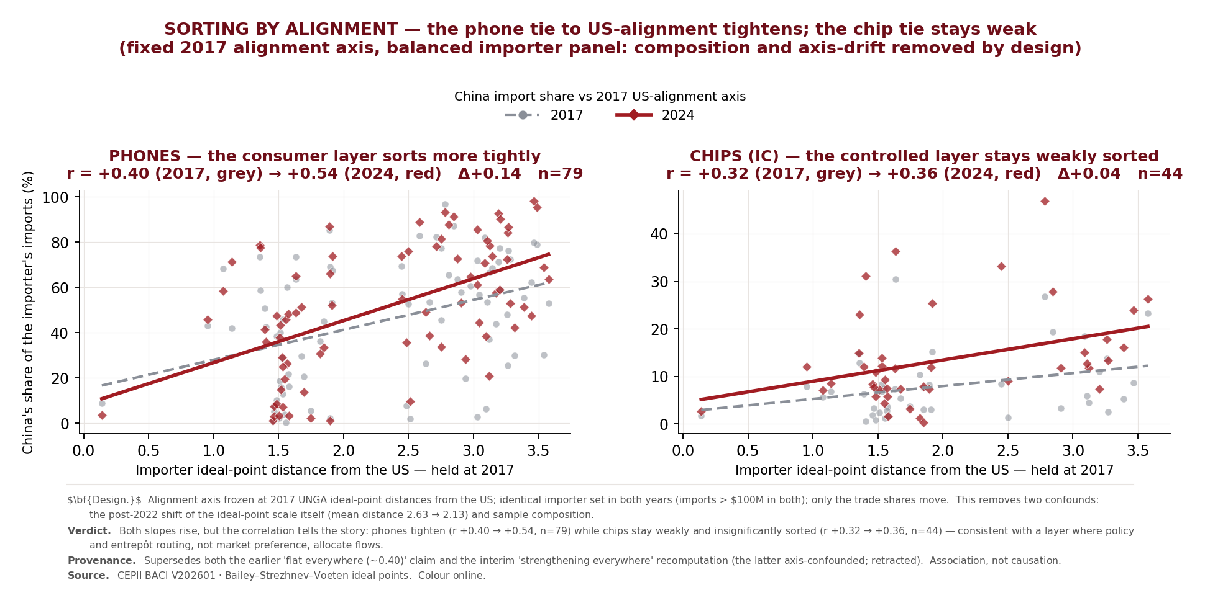
Appendix Figure A6. The Red Wave market by market, 2025 (Section 3). Structured caption embedded in-figure; final numbering at copy-edit. Graphic created by the authors; sources as stated in the panel and Appendix I. Calculations performed by the authors.

5. Remaining in-text Gartner mentions (inventory)
For completeness, every other occurrence of "Gartner" in the manuscript body, with local context (ellipses ours):
# | Context
1 | … endors, Mattson and ACM excluded as US-HQ, raw-confirmed from the original Gartner workbook); phone-heading vintage seam reported explicitly (+2.5/+3.5/+5.6pp, ~$30bn 2022). Figures F1/F10/F …
2 | … rated to canonical values. Numbers verified against raw BACI V202601 + raw Gartner + the original WFE workbook; HS-basis robustness (three bases, sign and rank invariant) in the reproducibil …
3 | … added, and 7.0 percent if Mattson is too; both are US-headquartered in the Gartner classification and are excluded from the strict measure). These are not small bases in levels: Chinese-bran …
4 | … revenue by device category and end-demand application, covering 2009–2025 (Gartner; see the data availability statement). We use leaf-level rows only (no aggregates), classify producers by h …
5 | … r devices. Market data. Market-share levels come from the latest available Gartner vintage for each layer; endpoint years (2011, 2019, 2025) are stable across vintages, while intermediate-ye …
6 | … while intermediate-year readings can shift by up to roughly 0.75 points as Gartner restates. Trade data. International trade flows come from the CEPII BACI database (Gaulier &amp; Zignago, 2 …
7 | … II BACI V202601, the most recent mirror-reconciled vintage (through 2024); Gartner market data extend through 2025, and the two horizons are stated per exhibit. We deliberately do not extend …
8 | … wnership. Every ownership claim in this paper derives exclusively from the Gartner firm-level panels, and Section 5.5 confronts the two rankings rather than conflating them. Estimation hygie …
9 | … 0.15, with chip and year fixed effects throughout (Panel B). Decomposed by Gartner’s seven demand industries (the binary indicator pools the five non-computing ones), the premium is consumer …
10 | … edger, and our territorial discipline is its precondition; the taxonomy is Gartner&#8217;s; causal language is bounded &#8212; a nested-logit probe (OS-based nests, a population outside opti …
11 | … ctors, devices, wafer-fabrication equipment) are proprietary and licensed (Gartner) and cannot be redistributed; the construction record, full replication code with anchor assertions, and al …
12 | … . Including the chapter-90 metrology and inspection tools that fall within Gartner’s WFE definition (HS 903082 and 903141), the WFE-inclusive import bill is about $31 billion in 2018 and $50 …
13 | … 2025 share of 5.9 percent, verified vendor-by-vendor against the original Gartner rank report. Mattson (US-headquartered despite its 2016 Beijing E-Town acquisition) and ACM Research (US-in …
14 | … Research (US-incorporated parent) are classified outside the strict set by Gartner headquarters coding; including ACM adds 0.7 points and adding Mattson a further 0.5. Appendix H. The electr …
15 | … he first author from the raw source data (CEPII BACI V202601; the licensed Gartner market panels; the Bailey&#8211;Strezhnev&#8211;Voeten UN ideal-point estimates) and verified against a sea …
16 | … EPII BACI trade data, and the other sources cited; no graphic reproduces a Gartner-published exhibit. All derived statistics, aggregations, harmonized panels, and econometric estimates repor …
17 | … this paper are calculations performed by the authors and do not represent Gartner published data. Gartner data and other-source data are not commingled within any single graphic; where a fi …
18 | … ions performed by the authors and do not represent Gartner published data. Gartner data and other-source data are not commingled within any single graphic; where a figure pairs perspectives …
19 | … urces, each panel is a separate graphic with its own source line. Panel A. Gartner data documents used (market-share workbooks). Analyst bylines for data deliverables appear on each document …
20 | … ks). Analyst bylines for data deliverables appear on each document&#8217;s Gartner landing page and are listed there rather than in the workbook; full bylines will be included at proof stage …
21 | … me series are enumerated in the reproducibility package manifest. Panel B. Gartner methodology documents (definitions and methodology; analyst bylines as printed). Title ID Published/Refresh …

